North Central Chapter, Health Physics Society
Business Meeting Minutes
Beckman Coulter - Chanhassen, Minnesota
October 19, 2007

Called to order at 3:15 P. M. by Dan McGrane, NCCPS President.
- The chapter recognized and thanked the host and vendors who sponsored the Spring 2007 meeting:
Host: David Paulu – University of Minnesota, MN
Vendors: Global Dosimetry (Tom Chwiert), Image Technology (Barb Johnson) and Philotechnics (Tom Klett). This meeting was sponsored in part by the generous contributions of Mayo Clinic, Nuclear Management Company and 3M.
We welcomed new officers and councilors (Start date is10/20/2007).
  - Vice President - Dan Miron Cardinal Health, WI
  - Councilor – Leola DeKock WI Dept. of Health and Family, WI
  - Councilor – David Paulu -University of Minnesota, MN
  - Secretary/Treasurer – Kimberly Knight-Wiegert MCW, WI
- The Spring Business Meeting minutes from 2007 were discussed and approved. The minutes were accepted as written and will be posted to the web site.

- Kimberly Knight-Wiegert presented Secretary-Treasurer's report. It was accepted and approved.
  - Checkbook balance: $3,606.71
  - Savings account: $2,867.89
  - Money Market fund: $16,092.60
  - Total balance: $22,567.20

The chapter has 104 full time members (four new members since fall 2007), 14 emeritus members and 9 affiliates. Constant budget items are the $500.00 Science Teacher Award, a travel stipend of $300.00 if the teacher comes to the meeting and the $500.00 Wissink Memorial Lecturer speaker stipend.
New Members:
- Wayne Britz – White Bear Lake, MN
- William Geisler – Marshfield, WI
- LeRoy Miller – Eyota, MN
- Regina Miller – Eyota, MN

- We reviewed the affiliate coordinator's report from Chris Kessler. The North Central Chapter of the Health Physics Society (NCCHPS) has 9 affiliate members for the calendar year 2007 to date generating $225 in annual affiliate fees. HI-Q Environmental Products Company renewed their affiliation in June (since the spring meeting). The NCCHPS web site reflects the current affiliate members.
Affiliates include;
- ADCO Services, Inc. (Len Warbiany)
- Global Dosimetry Solutions, Inc. (Tom Chwierut)
- HI-Q Environmental Products Company (Marc Held)
- ICX Radiation (Dale Elmore)
- Image Technology (Barbra Johnson)
- Landauer (Gary Beardman)
- Philotechnics (Michele Patterson)
- S&G Enterprises (Mark Griffith)
- Scientific Instrument Sales (Richard Love)
A copy of the Affiliate Members Report is on file with the secretary/treasurer.
- Mike requested and received 4 CEC credits for the fall 2007 meeting. The course number is 2007-10-001.

Old Business:
1.) Science and Education Committee update:
Jason Flora announced that Mr. Larry Scheckels from Tomah High School, won the 2007 Geoffrey Eichholz Outstanding Science Teacher Award given by the Health Physics Society.

National Student Science Award Winners were Shala Hawes and Haley Burgess from Central Lee High School in Iowa. They developed a project to test ground water for radon. They received grants from the University of Iowa Hygienic laboratory and the Iowa Academy of Science to permit them to gather samples and travel to the University of Iowa to analyze those samples. In addition, Shala and Haley were selected as recipients of the HPS 2007 National Student Science Award. Both received plaques and $250.00 cash prizes. We plan to invite then to attend our spring chapter meeting and receive our congratulations. We thanked the Science and Education committee members, Jason Flora, Chair, Travis Beard, Gary Yarrow, Mike Lewandowski and Ken Kerns.

Mike Lewandowski discussed the marketing strategy for the STW. He put together handouts for both the STA and NSSA which can be found on the table in the back of the room. It was noted that Marcum Martz attended the HPS Science Support Committee (SSC) at the HPS Portland Meeting. The HPS has offered $5600 to help us defray any cost if we decided to participate at the WI and MN conventions.

Mike Lewandowski discussed the proposal of buying equipment that would be available in the laboratory kit. Mike has a number of different options and pricing. Proposals revolve around purchasing, Vernier, LabPro modems and software & compatible radiation monitors. The vision is to allow teachers to use this equipment to reinforce basic nuclear science concepts including radiation penetration (shielding), the effect of distance on radiation, and radioactive half life. Mike will submit, via e-mail, the equipment purchase proposal to the Executive Committee for final review and decision. {Post meeting note. The equipment purchase was approved and the new Vernier components have been successfully utilized over the last four months.}

2.) Awards:

Dan McGrane received a plaque for the outstanding job he has put in as the Chapters President. The 2007 Chapter Award was presented to Dr. Genevieve Roessler for the long standing and exemplary support she has shown to the Chapter through her direct contributions to the Chapter and for her unwavering support of the Chapter at the national HPS level. And Mr. Scheckel's received the 2007 Geoffrey Eichholz Outstanding Science Teacher Award.

3.) Website:
Since the last NCCHPS meeting, we have had one online ballot. The electronic voting was well received with 42 of 55 (76%) ballots cast online. Only a few minor issues related to passwords were identified. 28 members requested passwords and 18 of those people voted electronically. Two of the 28 cast paper ballots. By the next meeting we will have another online ballot and we can better determine if we need to work on the username/password situation. Mike Lewandowski will put together a paper or electronic survey. This poll would ask members for feedback regarding on-line balloting. He is hoping to submit this to all members by May or June. Below are some of the questions that we could include;

- Did you vote on-line? (Y/N)
- If no, why not? (prefer paper ballot, didn't know about on-line option, didn't know where to vote, didn't know password, problems with voting site, other-please explain)
- If yes, did you have any problems? (Y-please explain, N)
- What method of voting do you prefer for future ballots? (on-line, paper)
- Please include any comments on the use of on-line balloting:

Mike received approval from the executive council to move forward with his survey.

4.) Instrument kits:
STW committee members are been looking into developing instrument kits that would contain suitable GM-based instruments, materials, and sources to perform simple nuclear physics and health physics experiments. The chapter has two instrument cases and instruments donated by the Minnesota Department of Health to use toward this goal. These instrument cases are currently located at the Medical College of Wisconsin and 3M. The Executive Committee is encouraged with the current progress and looks forward to further development of this project.

New Business:

1.) New Member Applications:

The executive council approved 4 new members, Wayne Britz – White Bear Lake, MN; William Geisler - Marshfield, WI; LeRoy Miller – Eyota, MN; Regina Miller – Eyota, MN. There is only one new affiliate since 2007 spring meeting, HI-Q Environmental Products Company, San Diego, CA. All applications were reviewed and signed.
2) Spring 2008 meeting location:
The spring 2008 meeting location will take place at Iowa State University, Ames, IA. Executive council meeting location will be determined at a later time.

3.) Local Arrangement Committee:

Jan Braun talked about heading up the local arrangement committee for the 2009 National Health Physics Convention which will take place in MN. We will be distributing a e-mail soliciting members for a second LAC co-chair.
Active committee members:
Affiliate Coordinator – Chris Kessler
Website Coordinator – Mike Lewandowski
Local Arrangements Committee Co-chair – Jan Braun
Science Teacher Award Chair – Jason Flora
Science Teacher Workshop Chair – Mike Lewandowski
President: Dan McGrane
President-Elect: Mike Lewandowski
Secretary Treasurer: Kimberly Knight-Wiegert
Councilor: Jafari, Johns, Simpson, & Yarrow.
Other Business:
1.) Public Relations Brochure:

George brought up the subject of "Public Relations" and the possibility of creating a NCCHPS brochure that would promote the chapter. This brochure could be both electronic and/or hard copy and should explain what the chapter has to offer. It would be very basic so that the public or anyone reading it will understand what we do and whom we are. We discussed contacting Kelly Classic a resource and that we could use art work from the website.
Meeting adjourned at 4:15 pm.
Respectfully Submitted,
Kimberly Knight-Wiegert, NCCHPS Secretary/Treasurer

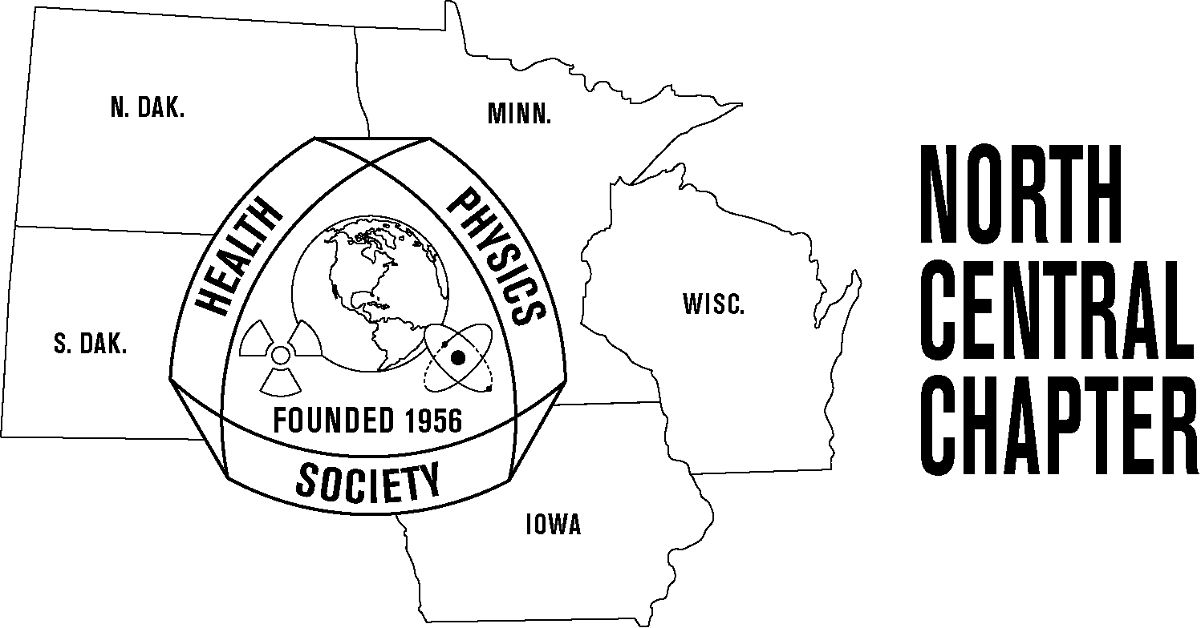
North Central Chapter

Health Physics Society

Business Meeting Agenda

October 19, 2007

Snyder Auditorium
U of M Landscape Arboretum

Chanhassen, Minnesota

- Call to order.
- Review of last April (07) meeting minutes.
- Secretary/Treasurer’s report.
- Affiliates reports.
- Meeting details.
AAHP CEC's for the meeting. Four credits. (2007-10-001)

Old Business

- Science & Education Committee update.
  - Science Teacher Award Committee (Jason Flora).
  - Science Teacher Workshop Committee (Mike Lewandowski).
- HPS awards.
  - Science Teacher Award - Mr. Larry Scheckel, 2007 Outstanding Science Teacher Awardee (Dan McGrane).
  - National Student Science Award (Mike Lewandowski).
- Other old business.

New Business

- New members.
- Spring 2008 meeting location – Iowa State University, Ames, IA.
- Chapter Award
- Local Arrangements Committee.
  - Jan Braun - Co-chair
- State of the Chapter, Dan McGrane
- Other new business.

